**What is a Chatbot?**

A chatbot also called as Chatter Robot is an Artificial Intelligence (AI) software that can simulate a discussion (or a talk) with a user in common language via messaging applications, sites, mobile apps or through the phone. Chatbots are at the talking point of the business world at this point. A Chatbot mimics human talks in its natural format using AI techniques such as Natural Language Processing (NLP), image and video processing, and audio analysis. The advent of chatbots have unlocked new domains of the customer engagement and better ways of doing business in the form of conversational commerce. It is one of the most beneficial technologies that organizations can depend on, perhaps replacing the old-style models and making apps and websites redundant. The most exciting feature of the chatbot is that they learn from the previous interactions and become intelligent and smarter over the time.

**Significance of Chatbots In Business**

We are living in an age where clients are tech- savvy, always connected to social media via their smart phones. This new generation of customers expects unified customer experience from the brands they engage with. They demand near real time reply to their questions and expect more personalized recommendations from the brand. To satisfy these client demands and to address the cumulative rivalry in the business space, businesses are revolving their effort to build chatbots that can manage customer questions round the clock without any delay. In fact, chatbots engage their customers in the right place, right time and with the right information in a cost-effective way.

**Behind the scenes: How a chatbot works**

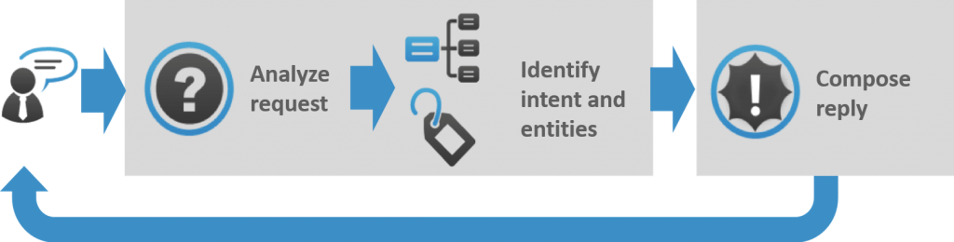

*As you can see in this graphic, a user request’s a query next it analyses the request then the identifies the intent and entities and a response is given to a user based on input. This process may look simple; in practice, things are quite complex.*

Why You Should Choose NUNC Systems As a Chat Bot Developer For Your Business

* Enhance the customer service experience
* Improve Customer Engagement
* Increase Your
* Business reach